**BASICS**

Tokens:

1.keyword(int, class, if, while, return, public)

2.constants/variables

3.special symbols({}, [])

4.seperators(‘,’ , ;)

5.operators

Shift Operators:

1.leftshift

2.rightshift

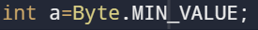

Used to find the min value of the Byte.

Replace it with MAX_VALUE to find the maximum value.

Similarly for Short, Int, Long

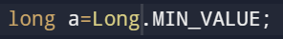

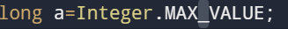





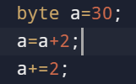 Error 32



(+=) it will also type cast the output

**MATHS**

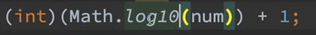 simplest method to count the no. of digits

Type convertion and casting:

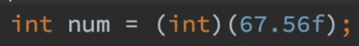

o/p=67

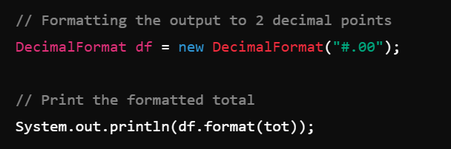

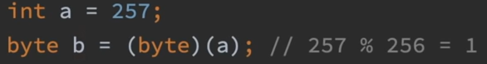

Byte value=256

Math.max(a,b) //maximum of two numbers

Math.max(C,Math.max(a,b)) //maximum of 3 numbers

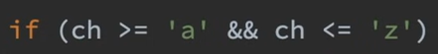

EOR:

|  |  |  |
| --- | --- | --- |
| a | b | a^b |
| 0 | 0 | 0 |
| 0 | 1 | 1 |
| 1 | 0 | 1 |
| 1 | 1 | 0 |

A^1 🡪 A complememt

A^A 🡪0

Number system conversion:

1.decimal to base b:

Keep dividing the base and take the remainder and write in opposite

2.base b to decimal:

Multiply and add the power of base with digits

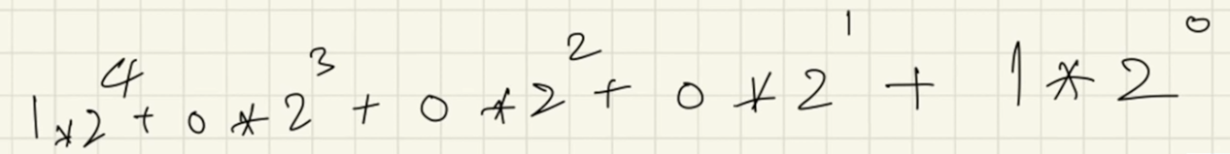

Left shift (<<)

* A<<1 == 2A
* A<<B == A*2^B

Right shift (>>)

* A >> B == A/(2^B)

Square root by Newton Raphson Method:

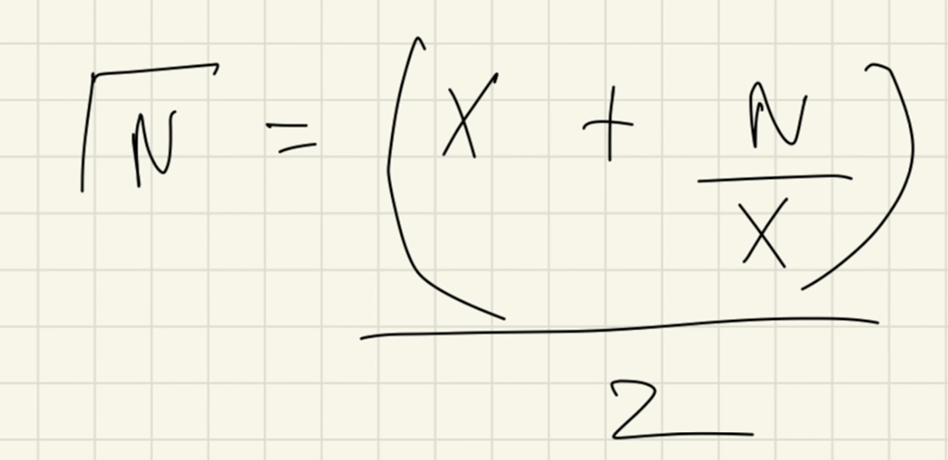Assumption value



**Integer to Binary:**

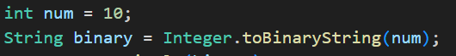

**Integer to string:**

int n = 42;

String str = Integer.toString(n);

**String to integer:**

Int a=Integer.parseInt(str);

**Long to string:**

String str = Long.toString(num);

**String to long:**

long num = Long.parseLong(str);

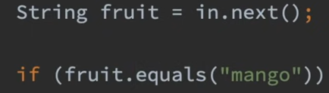

Equals():

Check the value and not the reference

Alt+enter -> to turn the normal switch statement to enhanced mode

NO pass by reference in java ONLY pass by value

**ARRAYS**

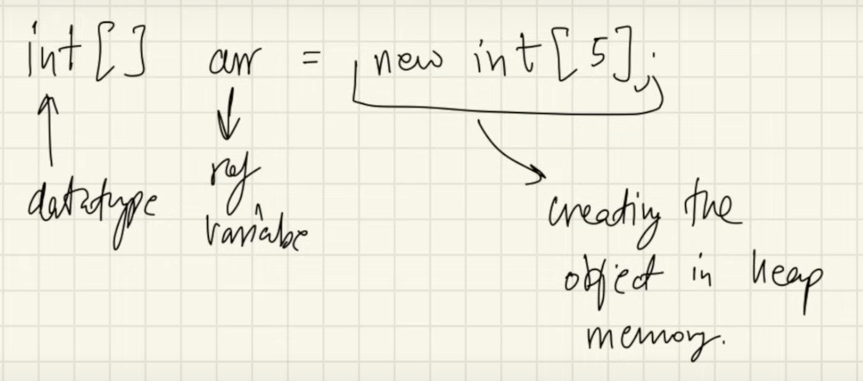

New[keyword] Is used to create an object

Array objects are in heap

Heap objects are not continuous

Dynamic memory allocation

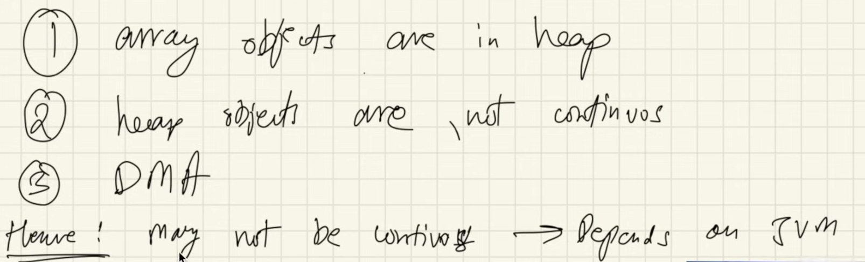

For each



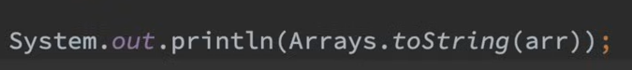

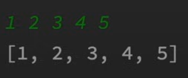

Arrays are mutable

2D Arrays

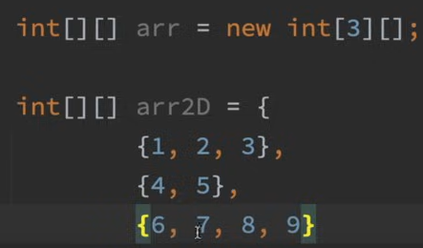

Mentioning the number of columns are not necessary because it can vary but we must specify the number of rows

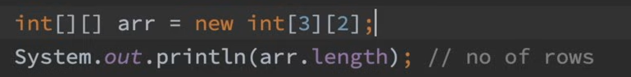

o/p: 3 [no of rows is three]

when the size of the col is not equal the program should count the length of the particular row

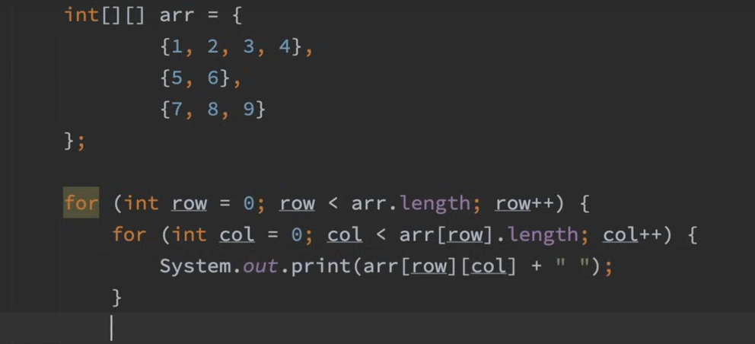



 ( old array , its height)



Arrays.copyOf() : is used to copy the same element in the array to the new array

**ARRAYLIST**

Syntax:



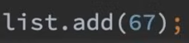 adding element

 returns true if the element is present in the list.

It also checks whether the element is present or not .

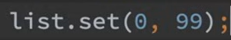 replaces the 0th element with 99

Eg: 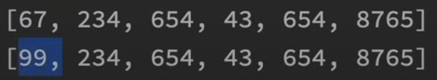

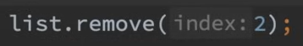 remove the element from the given index

 find the maximum element in the arraylist

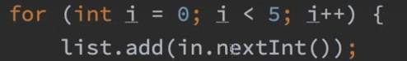 adding the element

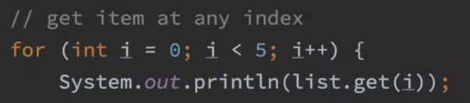

o/p: 

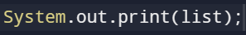

o/p: 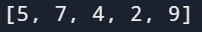

How can we store more elements in arraylist?

The size of the ArrayList is fixed internally. When it is filled by some element it will create a new ArrayList of double the size. Now the old ArrayList elements are copied and are stored in the new one and the old one is deleted.

Returning first 10 elements from the list





Recursion using arrayList:



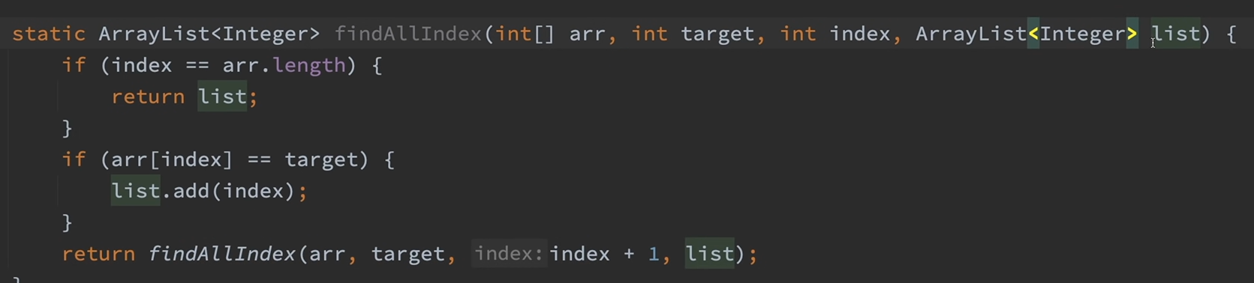

Return List without passing as an argument:

All the array list will not point on a single list and each function will point to a different object.

The list is written in the body.

Return type is list.

The next and previous function don’t know that the previous function have found the target element, this is because as no argument is passed in each of the function call a new list is created every time.

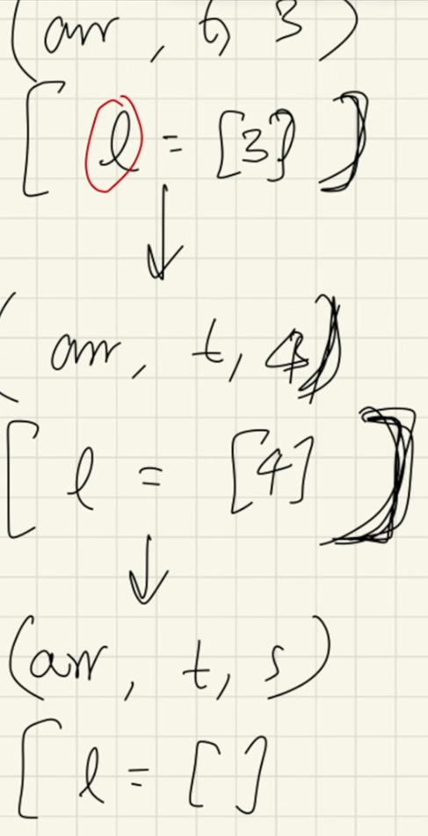

While returning from the bottom it will check for the elements in the list. If there are any element is present in the list it will be added in it and it will move to the above list to check and return it in the final list.

Function for the above:

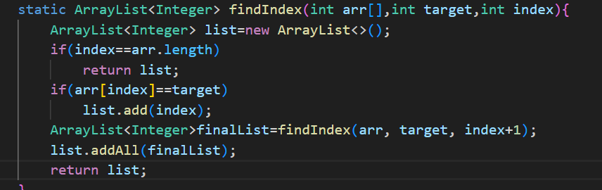

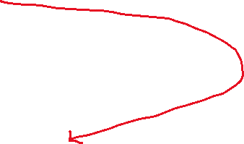

This is the list which will produce the final result

This is the list which will produce the result after every recursion runs

**Multidimentional ArrayList :**



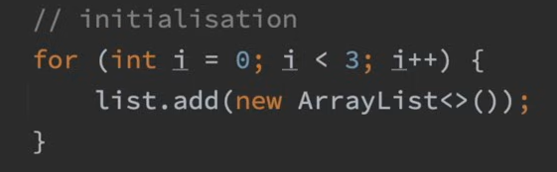

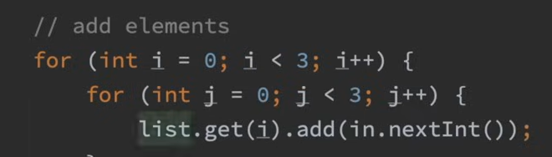

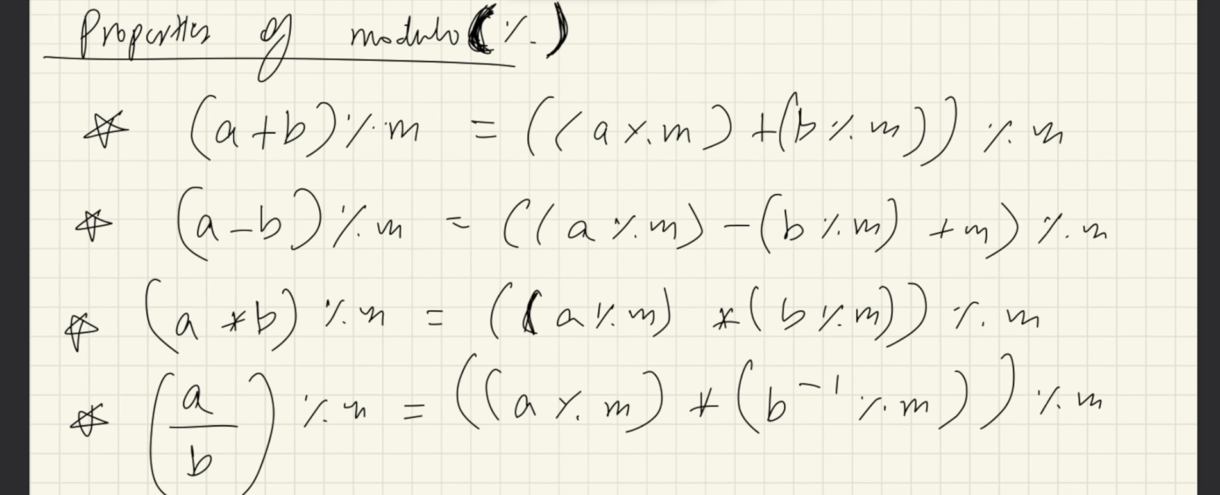

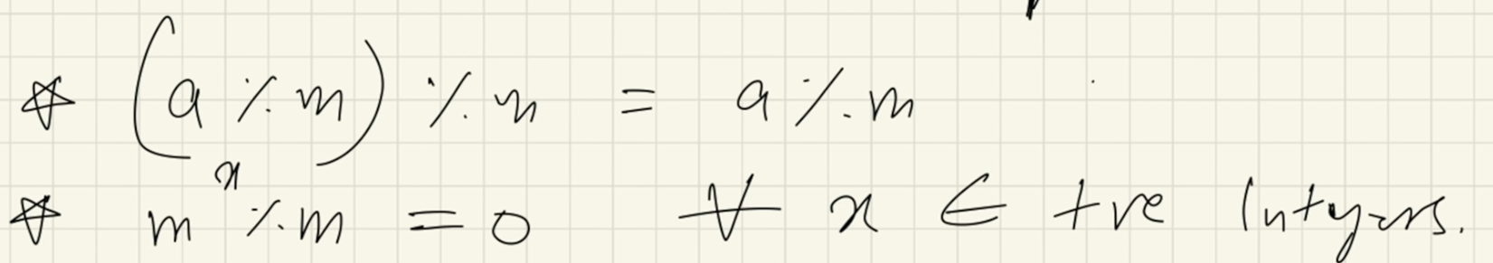

Count Prime (Leetcode-204):

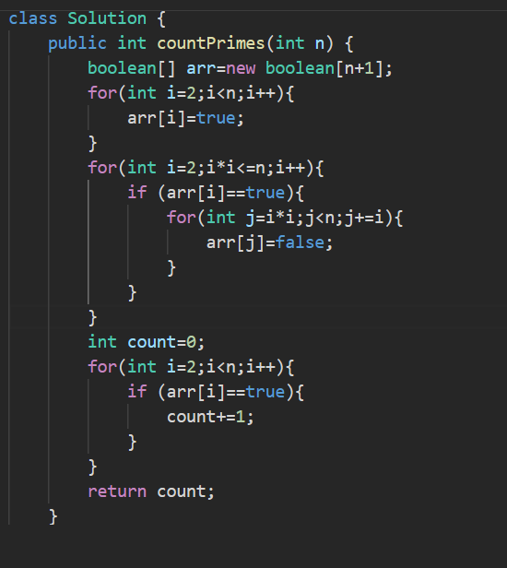



**BINARY SEARCH**

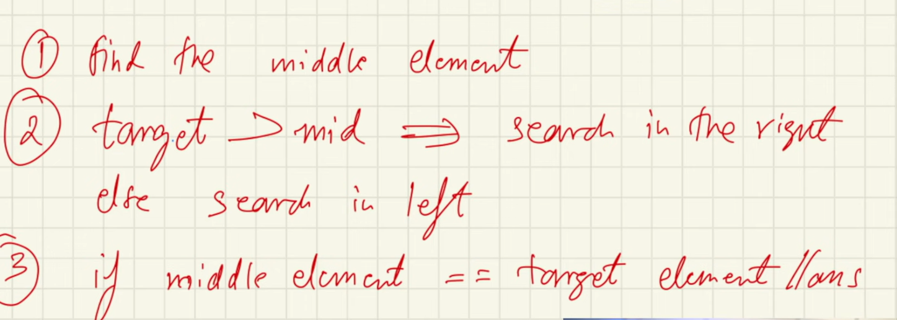

Alternate way to find the mid 

**BINARY SEARCH 2D**

Row and col are sorted:

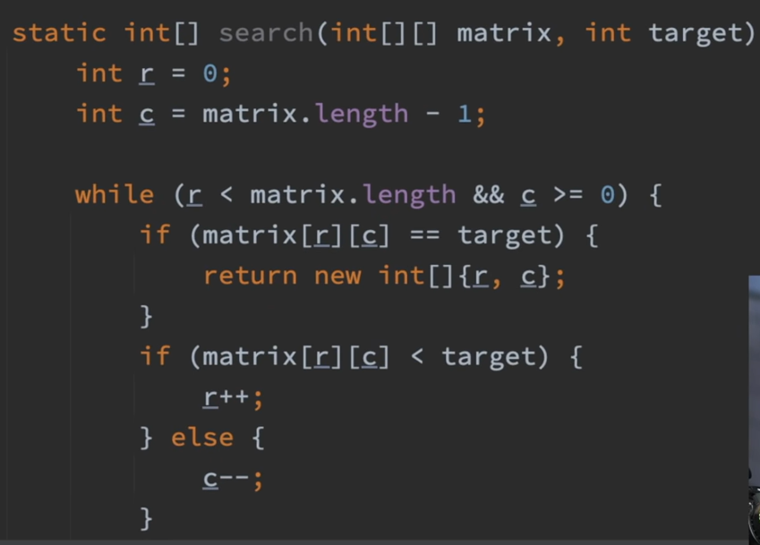 matrix[0].length-1

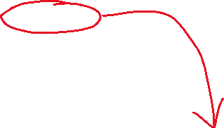

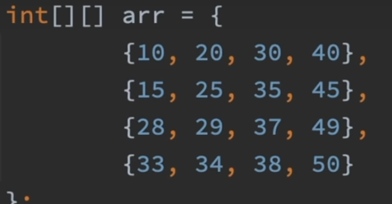 target=37

o/p: 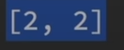

**Rotated Binary Search:**

[5,6,7,8,9,1,2,3]

Key=7

Conditions:

1.If arr[start]<=mid

If key>=arr[start] && key<=arr[mid]

End=mid-1

Else start=mid+1 the remaining portion

2.if key>=arr[mid] && key<=arr[mid]

Start=mid+1

3.else end=mid-1

Search in sorted matrix:

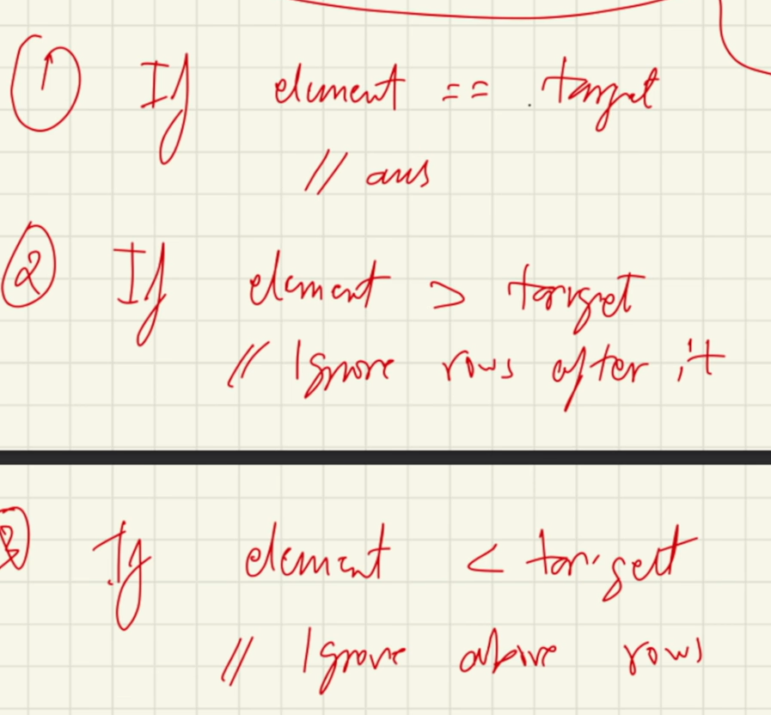 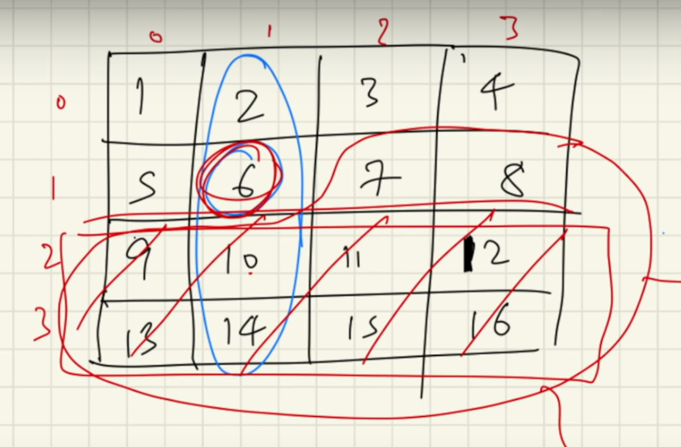

**BUBBLE SORT**

Time complexity:

Worst case: O(n^2)

Best Case: O(n)

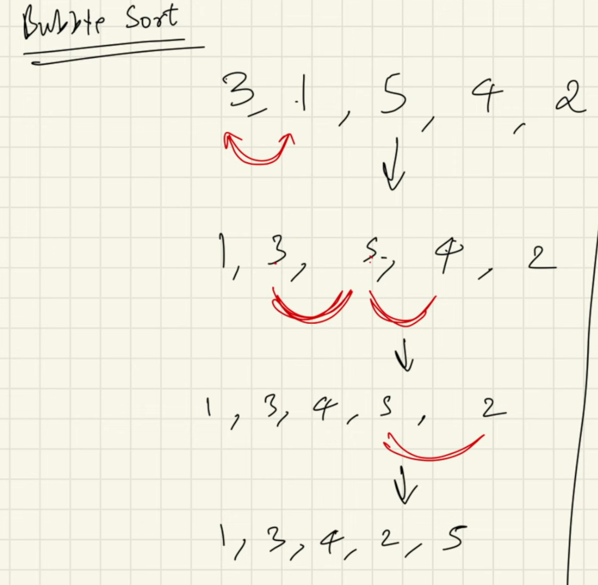 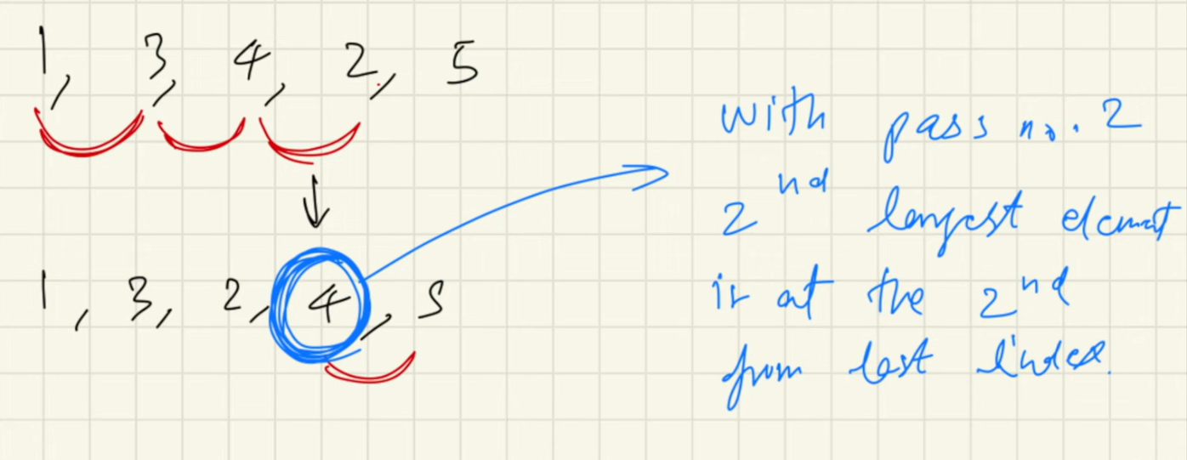



In every step the largest element that is present in the array will come to the last position

Also known as sinking sort / exchange sort

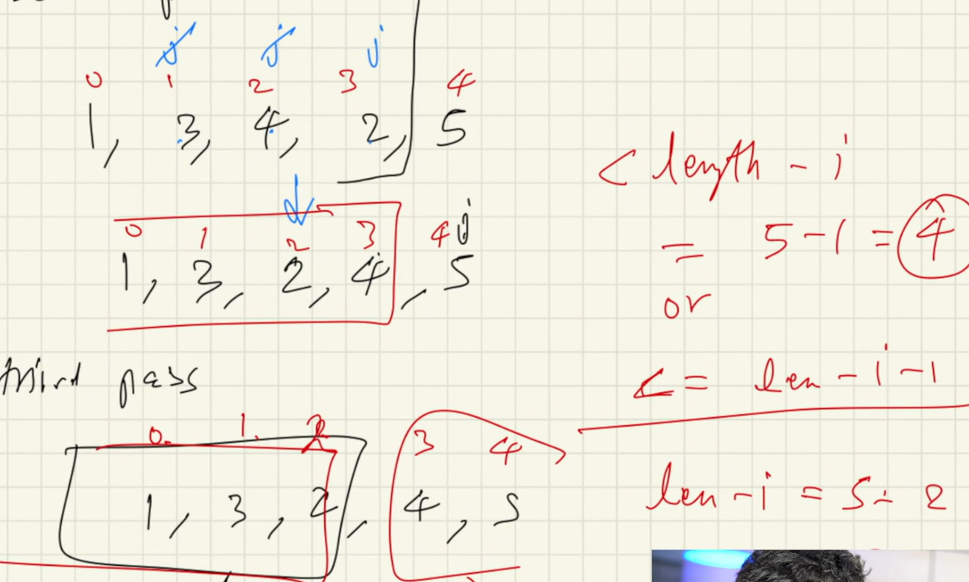

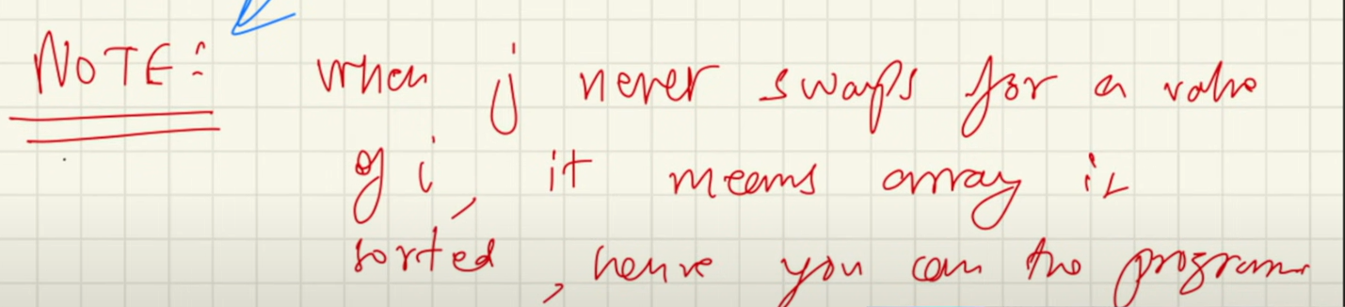

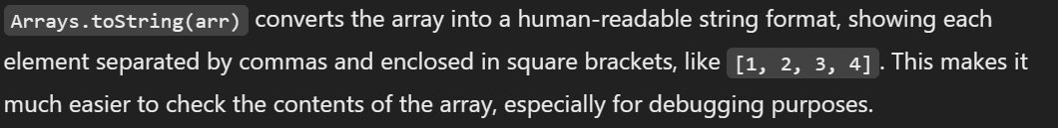

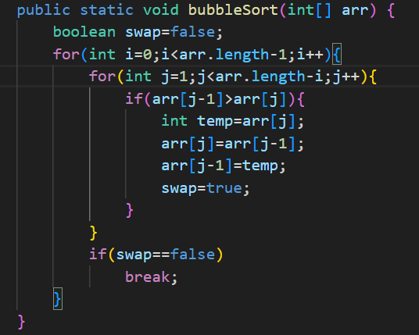

**INSERTION SORT**

Time complexity:

Worst case: O(n^2)

Best Case: O(n^2)

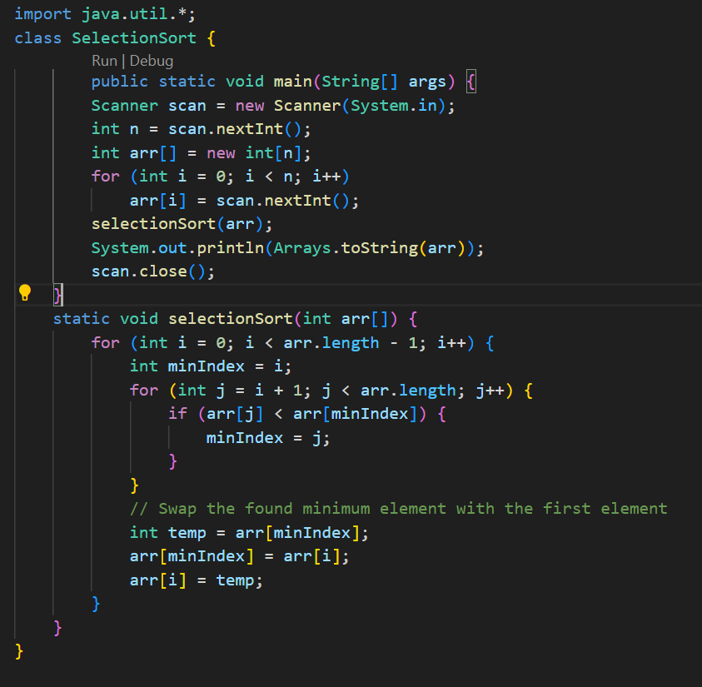

**INSERTION SORT**

Time complexity:

Worst case: O(n^2)

Best Case: O(n)

WHY WE USE INSERTION SORT??...

1. Adaptive: Steps get reduced if array is sorted. No. of swaps reduced as compared to bubble sort.
2. Stable
3. Used for smaller values of n. Works good when the arrays are partially sorted. So they are taken part in hybrid sorted algorithm.

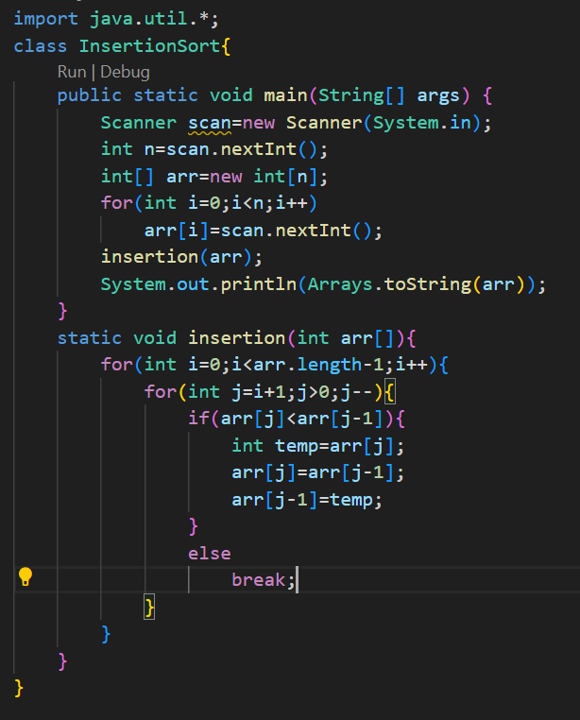

**CYCLIC SORT**

**These are used when number given from range **1 to N**

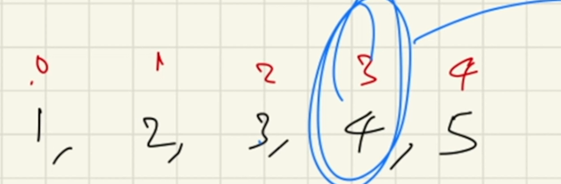 After sorting the indexValue=Element-1

Time complexity:

Worst case: O(n)

Best Case: O(n)

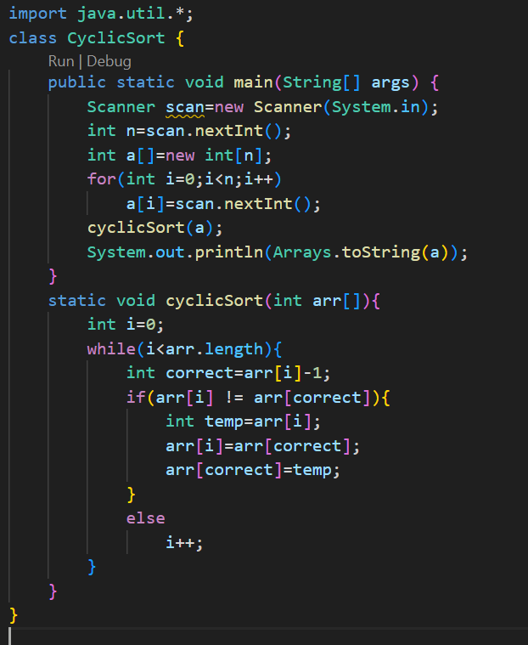

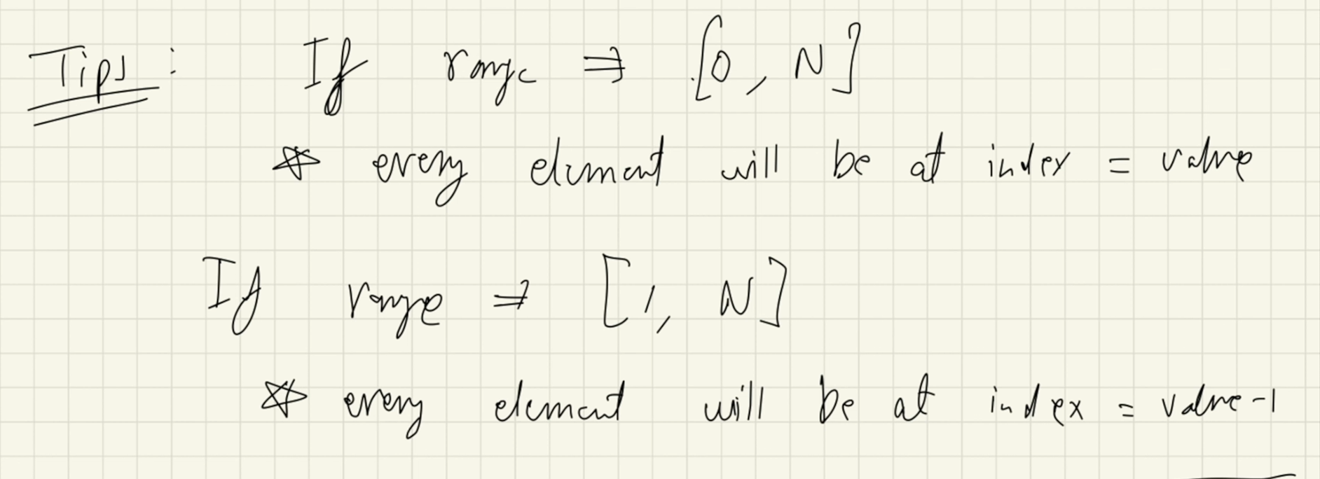

**Input:** nums = [4,3,2,7,8,2,3,1]

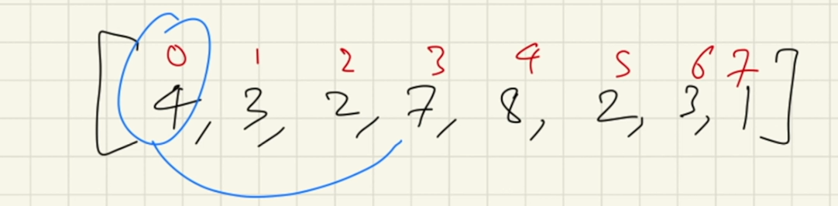

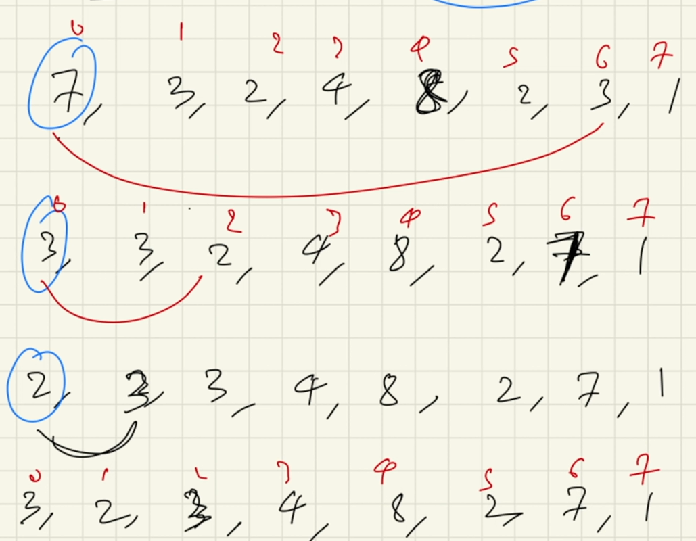

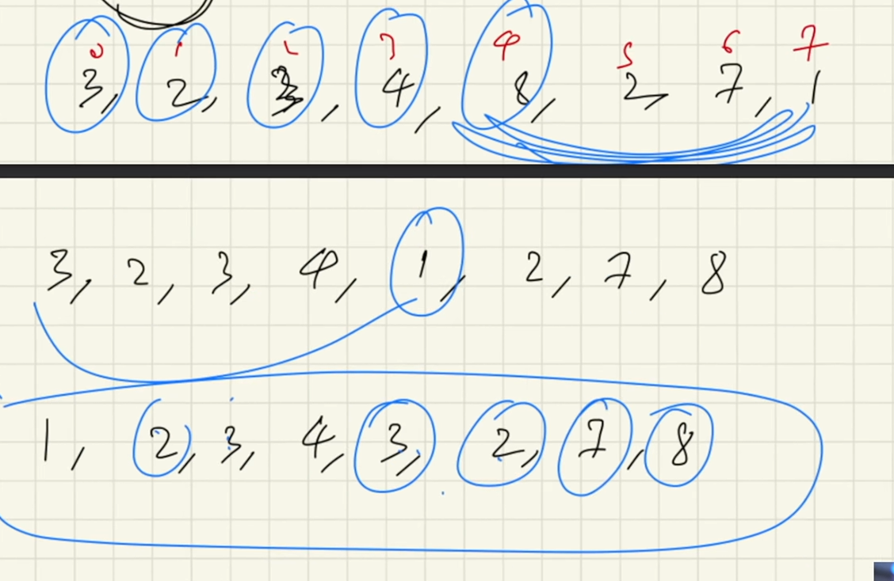

**Quick Sort:**

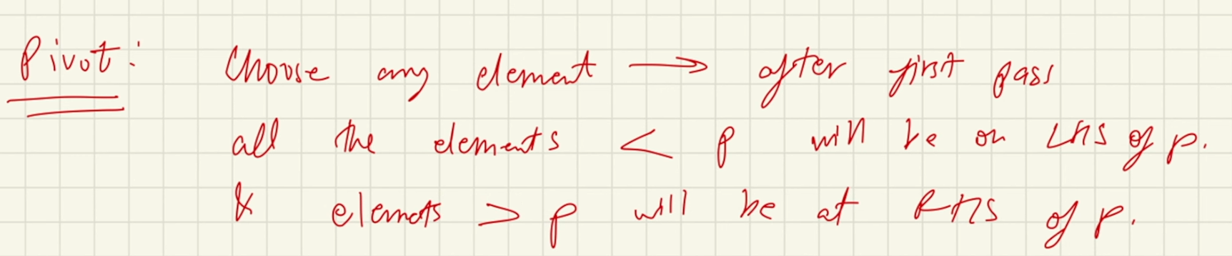

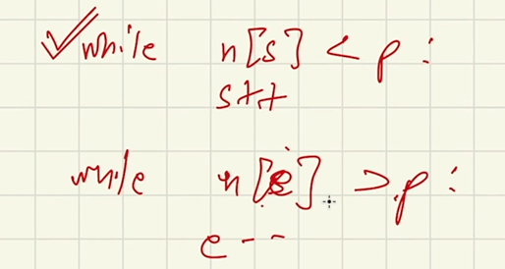

Recurrence relation of Quick sort:

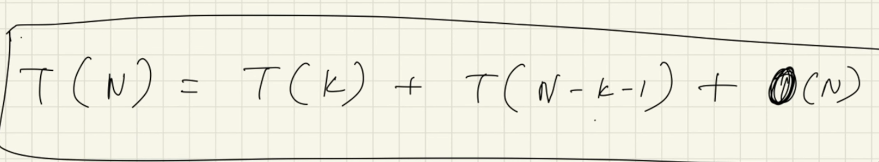

Time Complexity:

Worst case:

Happens when one part of the array is empty

O(n^2)

Best case:

Happens when the array is divided into two halves

O(N log N)

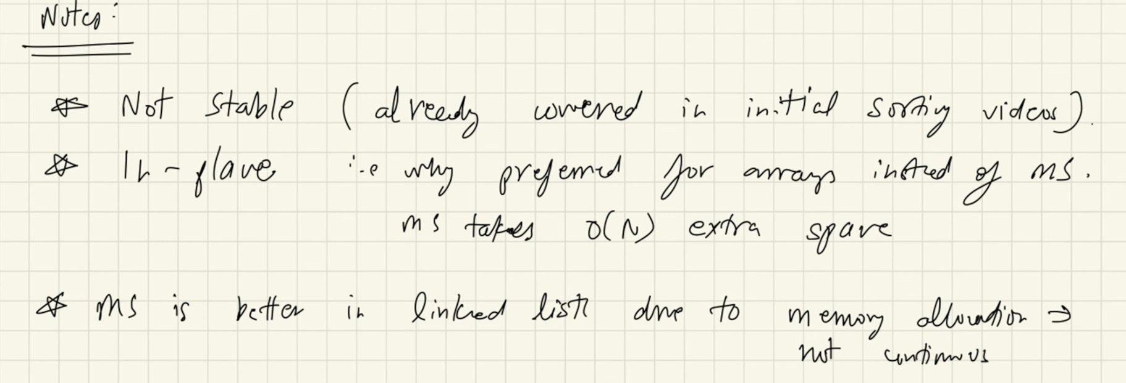

After every cycle the pivot will be at the correct position

How to find Pivot:

1. At the corner
2. At a random position
3. At the middle position



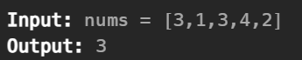

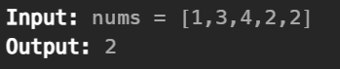

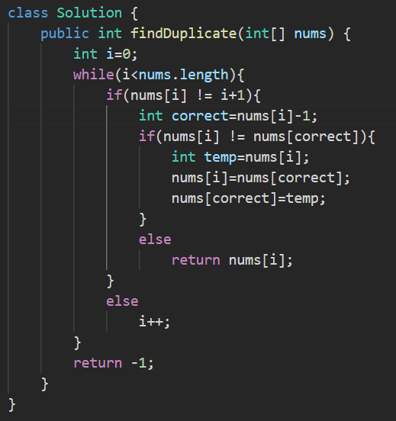

**STRINGS**

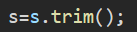 remove the extra spaces at the start and end of the string

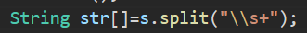 remove the extra spaces b/w the string words



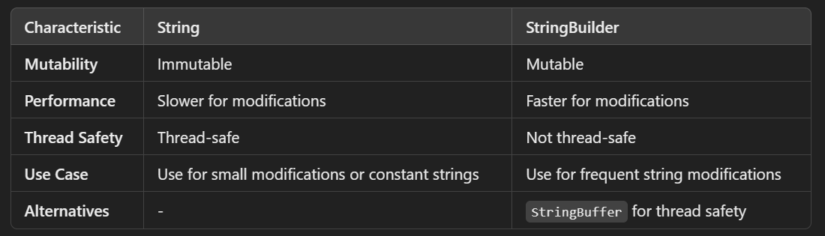

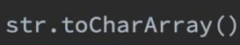 string to char array

Changing the string into int and taking the value of first and last value



 this will start from the index position 5 from the string

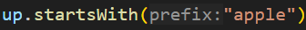 checks whether the string contains the substring “apple” at any position

String Pool:

It is a sperate memory structure inside the heap.

When you change the object with any of the one reference variable the another will not change this is because of the nature of immutability.

String name=”kunal”;

String b=”kunal”

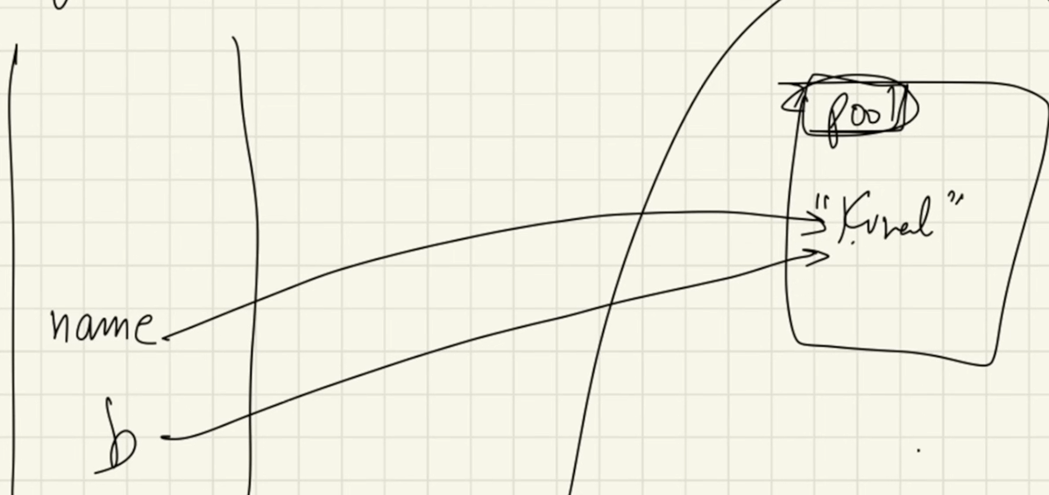 object reference variable



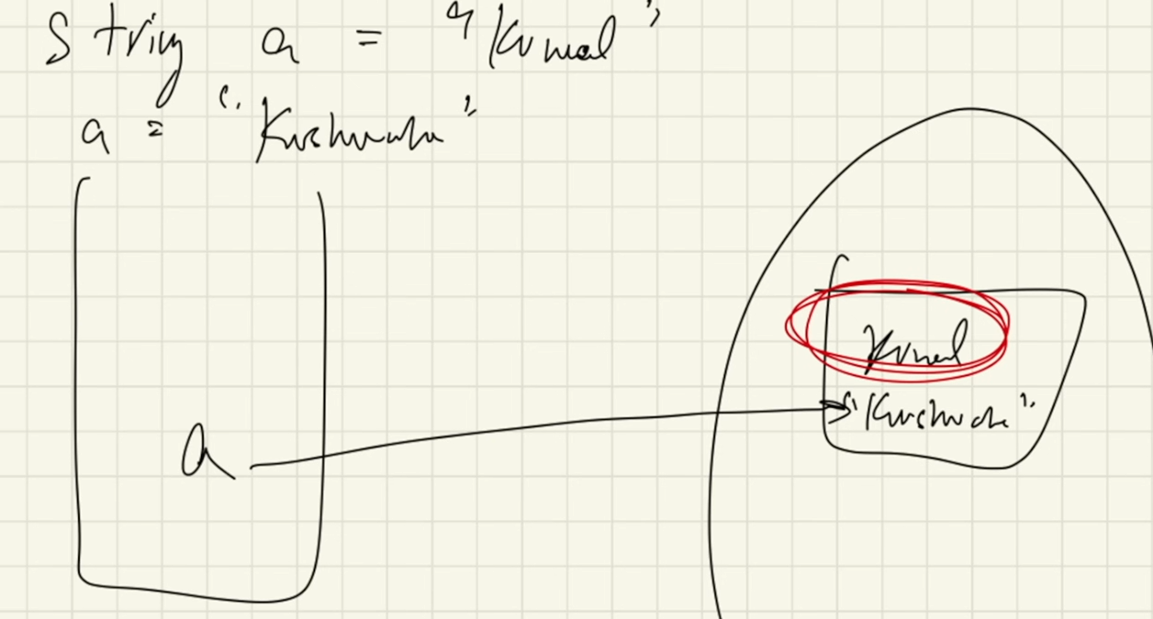 Old New



We did not change the object we just created the new one. The old one will be going to the garbage collection.

Comparison of Strings:

1. == method : Checks if the reference variable are pointing to the same object.
2. .equals method: Check the value.

How to create different object of same value?

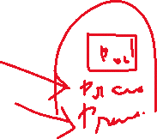

String a= new String(“Praveen”);



String b= new String(“Praveen”);

//This create the value outside the pool but inside the heap

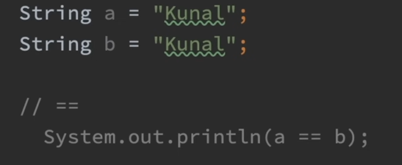 O/P: true

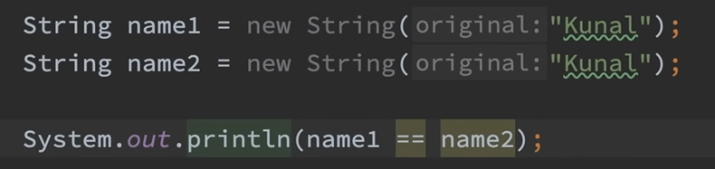 O/P: false (this is because however the value is same but the object is different and is outside the pool and within the heap)

 O/P: true (this is because it does not care about whether the reference variable is pointing to the same or different object , it just care about the value)

Format Specifiers in java:

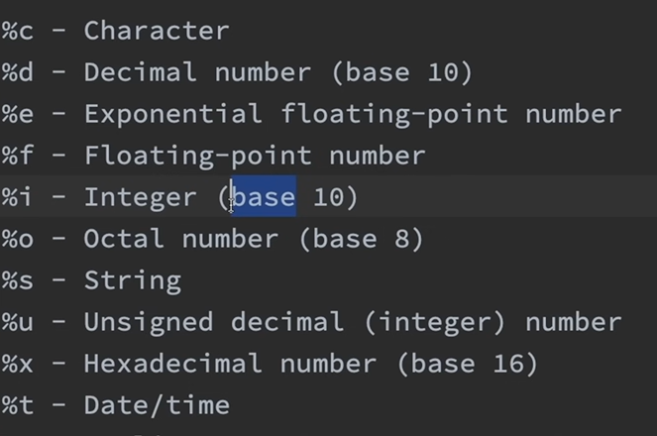

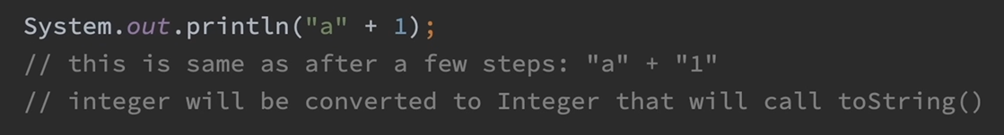



object

If there is any object it will call the tostring() function.

StringBuilder :



String methods:



O/P: 

.strip() : remove the spaces which are present at the start and end.

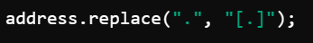 used to replace the letter in the string with another



String name Letter in the string replaced letter

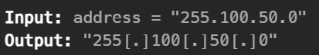

Remove spaces, special and digits characters and print only alphabets



Remove spaces and special characters and print only alphabets and digits



Split by space and store it in an array:

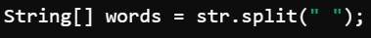

Remove special characters:arrayli

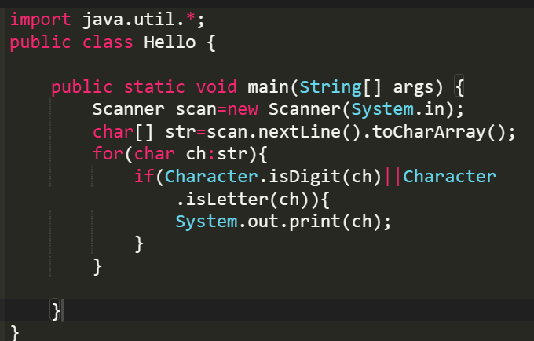

**Subsets:**

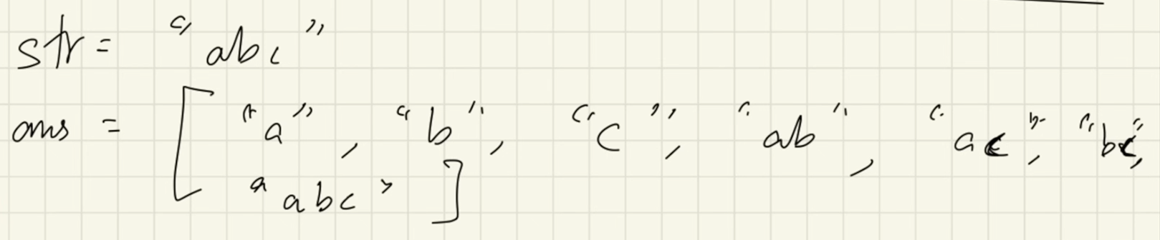

This pattern of taking some and removing some element is subset.

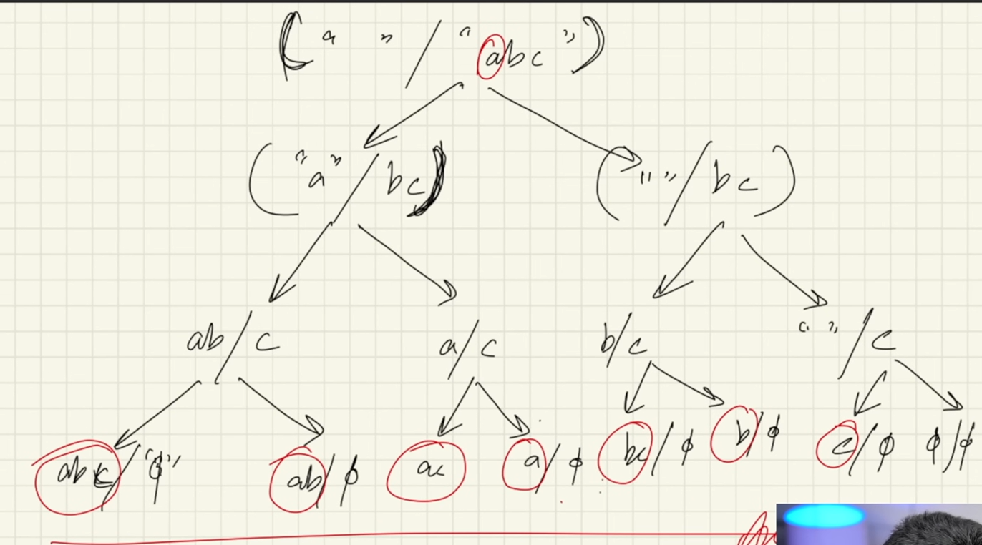

**PATTERNS**

How to approach?

See how many line is present in the pattern, then that many times the outer for loop will run.

Identify for every row number how many cols are there **or** the type of element is there.

What do you need to print.

Recursion in patterns:

**RECURSION**

Types:

Linear and divide and conquer

**NOTE:**

While a function is not finished executing it will remain in the stack.

When a function is finished executing it is removed from the stack and the flow of program is restored to where the function was called.

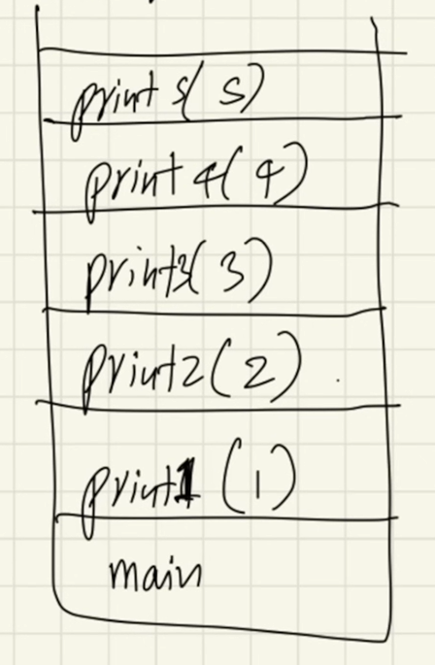 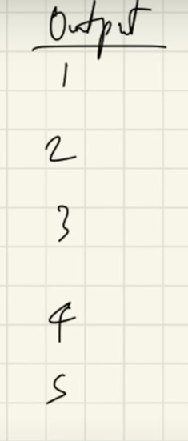 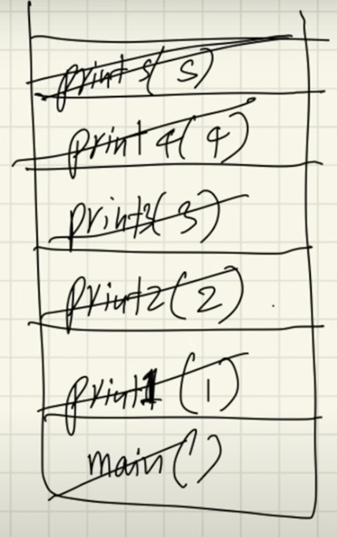

What is recursion?

A function that call itself

Function body is same

As many time as you call a function it will take memory separately

**Base condition** is a condition where our recursion stops making a new calls. If no base condition function will keep calling again and again the stack will be filled again and again. WKT every function will takes a memory simultaneously and leads to a situation where the memory of the computer will exceed the limit which leads to **STACK OVERFLOW ERROR**

Why recursion?

It helps us in solving bigger complex and problems in a simpler way

You can convert recursion solutions into iteration and vice versa

Space complexity is not constant because of recursive calls

It helps us in breaking down bigger problem into smaller problems

Steps:

Break it down into smaller problems

How to understand and approach a problem?

Identify if you can break down problem into smaller problem

Write the recurrence relation

Draw the recursive tree

About the tree

See the flow of function how they are getting in stack

Identify and focus on left and right tree calls

Draw the tree and pointer again and again using pen and paper

Use a debugger to see the flow

See how the values are returned at each steps and how the function call come out. In the end you will come out of the main function

Variables: Argument

Return type

Body of function

**\*\* if there are few variables that you need to pass it in the future function calls put it in the argument \*\***

**\*\* make sure to return the result of a function call of the return call \*\***

Types of recurrence relation:

1.linear

2. divide and conquer

**SPACE AND TIME COMPLEXITY**

What is time complexity?

* Time complexity is not equal to time taken
* It is the function the tells us how the time is going to grow when the size grows
* It is a function that gives us the relation about how the time grow when the input size grows
* While we are looking about time complexity always look for worst case complexity
* O(1) < O(log N) < O(N) < O(2^N)
* Always look at complexity for large infinite data
* 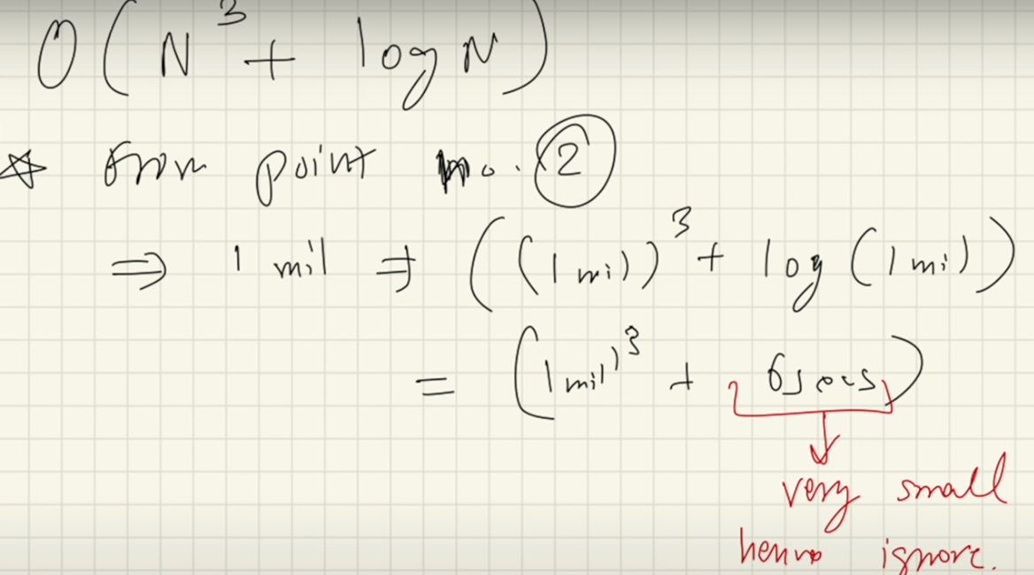Always ignore less dominating terms

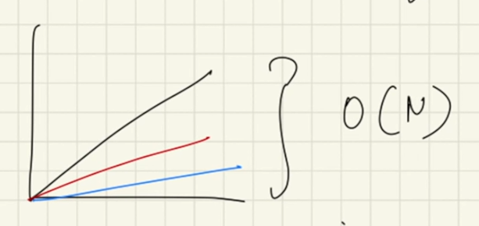

* Even though value of actual time is different they are growing linearly
* We don’t care about actual time
* This is why we ignore all constants

BIG-O NOTATION

O(N^3)-> upper bound (max 3 min can be 0,1,2)

The time complexity will not be exceed this

BIG-OMEGA NOTATION

O(N^3)-> lower bound(min 3 max can be anything)

Opposite of big-O notation

BIG-THETA NOTATION

When both the upper bound and lower bound is equal

LITTLE-O NOTATION

This is also giving the upper bound

Loose upper bound

Stronger statement

LITTLE-OMEGA NOTAION

This is also giving the lower bound

Loose lower bound

Space complexity

* Input space + auxiliary(extra) space

Space complexity of recursive tree is height of the tree

Divide and conquer recurrence relation:

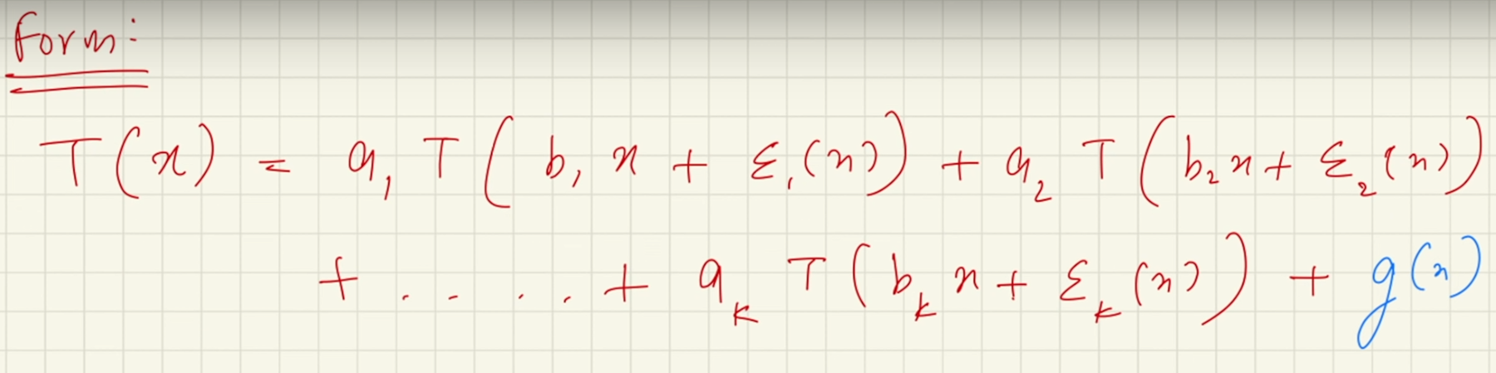

How to solve to get complexity?

1. Plug and jug
2. Master’s theorem
3. Akra bazzi (best)

Akra bazzi

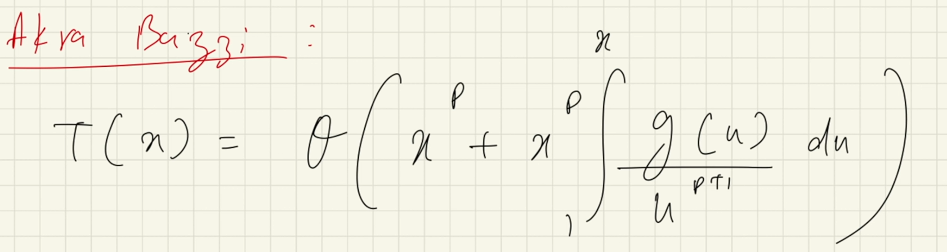

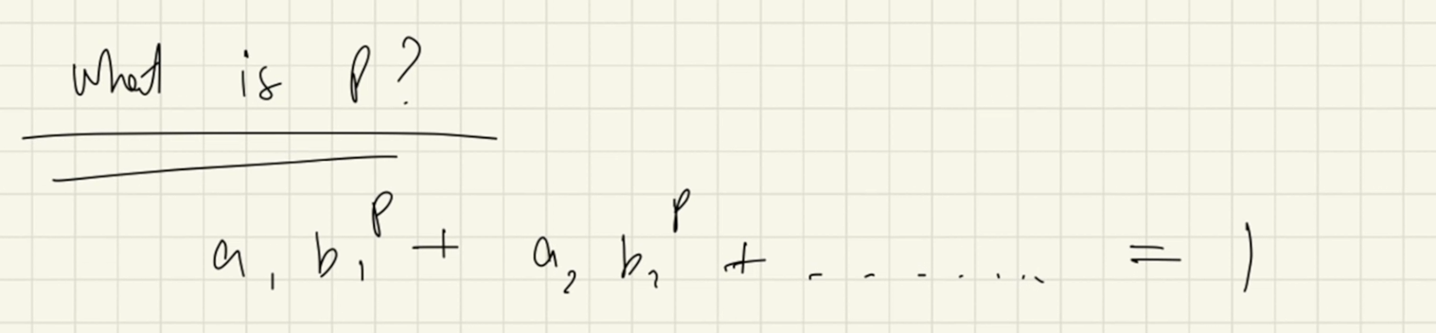

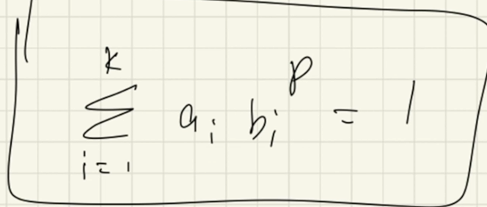

Linear recurrence relation:

Form

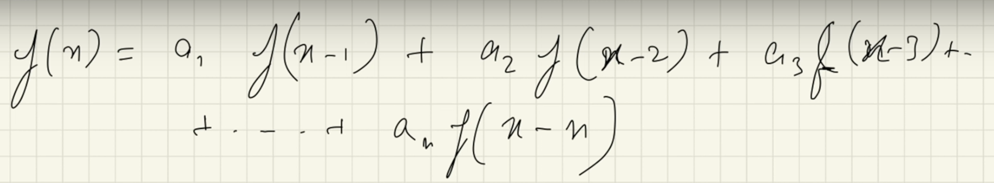

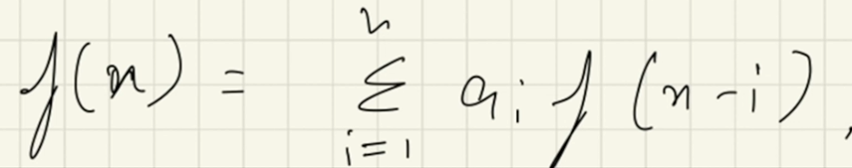

** Number of roots is equals to number of answers already **

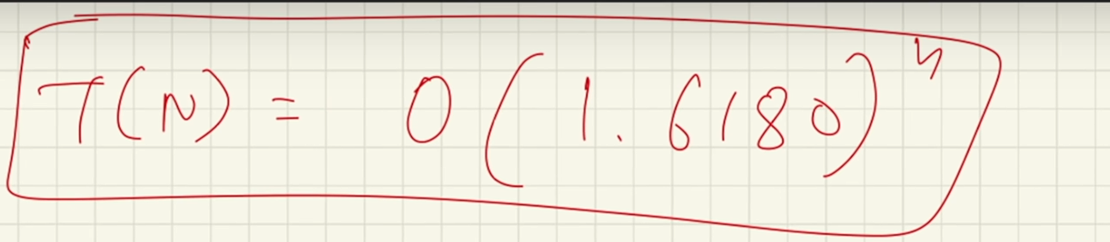

For Fibonacci number

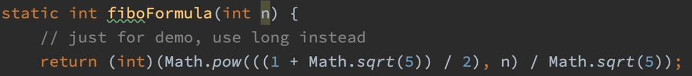

How do we find the particular solution?

If g(n) is exponential guess of some type

If g(n) is polynomial guess of same degree